Testing Tableau Report In MySQL

Employee Count : -

6KPICount.jpg

6Result.jpg

Attrition Rate:-

7AttritionRate.jpg  
7Result.jpg

Attrition By Gender:-

11AttritionByGender.jpg

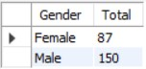

Department Wise Attrition:-

  
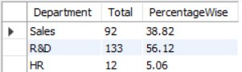

Gender By Attrition in Hr Department:-

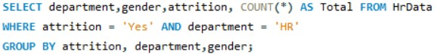

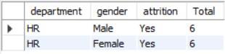

Gender By Attrition in R&D Department:-

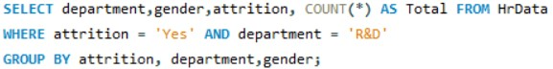

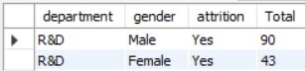

Gender By Attrition in Sales Department:-

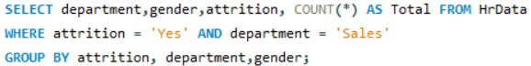

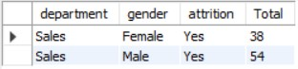

Attrition Rate By Age-Band:-

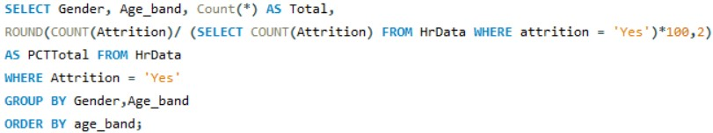

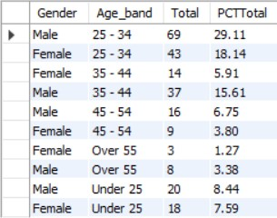

Job Satisfaction:-

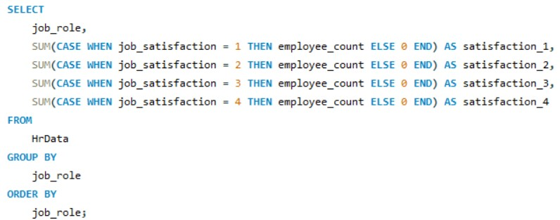

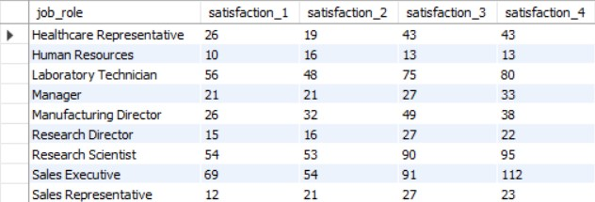

Attrition Count:-

16Attrition Count.jpg

16Result.jpg

Active Employee:-

17ActiveEmployee.jpg

17Result.jpg

Average Age Of Employee:-

12AvgAgeOfEmployee.jpg

12Result.jpg